Hooli XYZ

**Sprint 2 Report**

**Sprint Period:** 21/03/2016 – 12/04/2016

**Members:**

Connor Beardsmore – 15504319

Brendan Lally – 18407220

Adam Brown – 18338993

Jordan Chou – 18348691

Edward Lim - 18339145

**Table of Contents:**

1. Sprint Planning
2. SCRUM Meetings
3. Sprint Review
4. Sprint Retrospective

Appendix A: CSV of all user stories

Appendix B: Screenshots of Functionality

**1. Sprint Planning**

**User Stories:**

The following user stories were selected for completion in Sprint 2.

|  |  |  |  |
| --- | --- | --- | --- |
| Number: | User Story: | Area: | Effort Points: |
| 1 | As an Admin, I want to reset passwords so that I can help users regain access to their accounts. | Admin | 5 |
| 2 | As an Admin, I want to remove submissions so that I can remove inappropriate submissions. | Admin | 3 |
| 3 | As an Admin, I want to edit submissions so that I can remove offensive language. | Admin | 2 |
| 4 | As a User, I want to access user profiles so that I can view a specific user’s details. | Account | 5 |
| 5 | As a User, I want to post a submissions so that I can put my idea on the platform. | Posting Submission | 3 |
| 6 | As a User, I want to edit my submissions so that I can fix spelling errors. | Posting Submission | 2 |
| 7 | As a User, I want to delete my submission so that that I can remove my idea from the platform. | Posting Submission | 3 |
| 8 | As a User, I want to add images to my submissions so that I can show relevant images to my idea. | Posting Submission | 5 |
| 9 | As a User, I want to add videos to my submissions so that I can can show relevant videos to my idea. | Posting Submission | 5 |
| 10 | As a User, I want to view existing submissions so that I can see all past submissions posted. | Viewing Submission | 5 |

**Sprint Goal:**

The goal of Sprint 2 was to implement the submissions side of the platform and refine the user interface. By the end of the sprint, both users and admins should be able to post, edit and remove appropriate submissions. Submissions should allow entry of text, as well as both images and videos. Users should also be able to view other user’s profiles. Eight of our user stories for this sprint focus on submissions, with two others relating to other miscellaneous tasks. Submissions are the central pillar of the overall project and consequently, it is crucial they are implemented correctly.

**Task Breakdown:**

The user stories for the sprint were broken down into simpler high-level task units. These tasks must be finished before the user stories can be reviewed, accepted and completed:

* Host website via pythonanywhere.com
* Create submission model
* Create submission list page
* Create submission form
* Modify user accounts backend to include submissions
* Design user profiles template
* Add delete button to submissions list
* Add edit button to submissions list
* Implement methods to remove submission from backend
* Implement methods to edit submission in backend

**Task Distribution:**

|  |  |
| --- | --- |
| Members: | Area of Focus: |
| Connor | Viewing Submissions. (10). |
| Adam | Admin Platform. (1) (2) (3). |
| Jordan | User Profiles. HTML and UI. (4). |
| Brendan, Edward | Add / Edit / Remove Submissions. (5) (6) (7) (8) (9). |

**Effort Estimation:**

The estimations decided upon for this sprint were difficult to ascertain, given the team’s lack of experience with web development and design. The majority of the user stories associated with submissions were given ratings of 3. A potentially difficult aspect was the integration of images and videos into a submission, with this being reflected in the effort estimation. Viewing of submissions is also expected to take longer than average due to the extensive work setting up the UI “feel” of a user profile.

**Hosting:**

We were notified on the 4th April that the project client wishes our project to be hosted and accessible online. This was entered as a chore into Pivotal Tracker and completed within the sprint. The hosting was achieved via pythonanywhere.com, and the project is now accessible via the following links:

*cbeardsmore.pythonanywhere.com*

*bit.ly/curtinideas*

**2. SCRUM Meeting**

**Meeting #1 : 28/03/16**

|  |  |  |  |
| --- | --- | --- | --- |
| Members: | Completed | Uncompleted | Issues |
| Connor | (10) | - | UI needs enhancing |
| Adam | (2) (3) | (1) | Workaround resetting without Email server still underway |
| Jordan | - | (4) | Time constraints due to helping with submissions limited work on User Profile |
| Brendan, Edward | - | (5) (6) (7) (8) (9) | Submission form works. Modification needed to fix redirects after submitting. |

**Meeting #2 : 04/04/16**

|  |  |  |  |
| --- | --- | --- | --- |
| Members: | Completed | Uncompleted | Issues |
| Connor | (10) | - | Assisted Jordan with user profile |
| Adam | (2) (3) | (1) | - |
| Jordan | - | (4) | Users can access profile. UI needs finalizing. |
| Brendan, Edward | (5) | (6) (7) (8) (9) | Editing/deleting requires additional work on the user accounts and submission backend. |

**Meeting #3 : 10/04/16**

|  |  |  |  |
| --- | --- | --- | --- |
| Members: | Completed | Uncompleted | Issues |
| Connor | (10) | - | - |
| Adam | (2) (3) | (1) | Password reset will be pushed back to next sprint. Still struggling will how to implement. |
| Jordan | (4) | - | - |
| Brendan, Edward | (5) (7) | (6) (8) (9) | Will push stories (8) and (9) into next sprint for completion. |

**3. Sprint Review**

**Completed User Stories:**

* As an Admin, I want to remove submissions so that I can remove inappropriate submissions.
* As an Admin, I want to edit submissions so that I can remove offensive language.
* As a User, I want to view existing submissions so that I can sell all past submissions posted.
* As a User, I want to access user profiles so that I can view a specific user’s details.
* As a User, I want to post a submission so that I can put my idea on the platform.
* As a User, I want to delete my submission so that that I can remove my idea from the platform.

**Unfinished User Stories:**

* As an Admin, I want to reset passwords so that I can help users regain access to their accounts.
* As a User, I want to edit my submissions so that I can fix spelling errors.
* As a User, I want to add images to my submissions so that I can show relevant images to my idea.
* As a User, I want to add videos to my submissions so that I can can show relevant videos to my idea.

**Review Data:**

* Total Stories: 45
* Completed: 12
* Uncompleted: 33
* Total Progress: 27%

**Review Data:**

The statistics and data within the figures below were produced via the Pivotal Tracker software utilized by the team. They illustrate the progress throughout the current iteration and progress towards the final release.

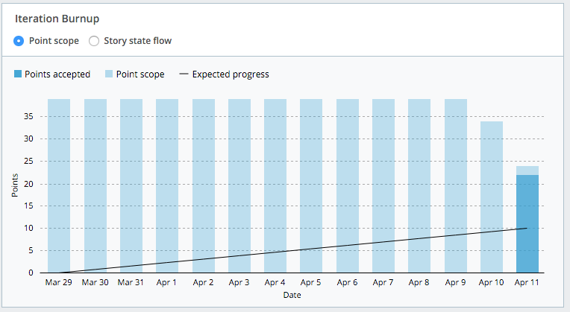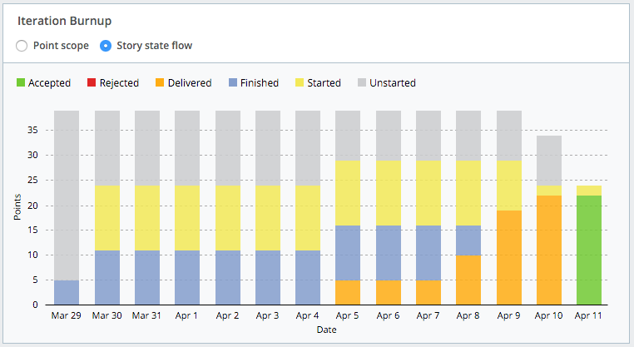

Figure 1: Iteration Burnup - Points and Stories

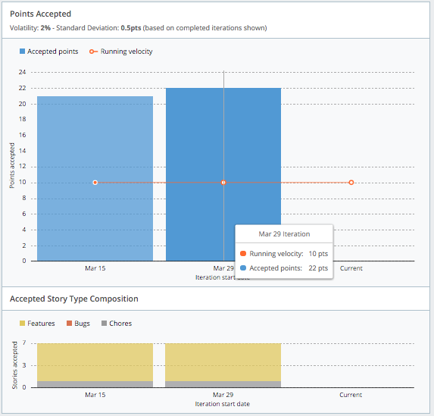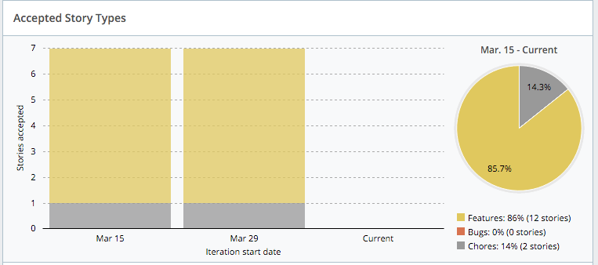

Figure 2: Points Accepted

Figure 3: Accepted Story Types

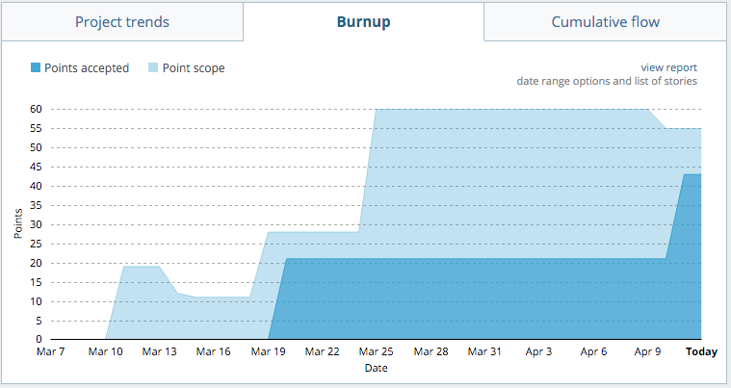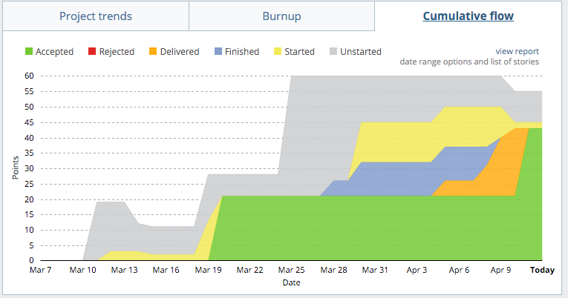

Figure 4: Overall Burnup

Figure 5: Cumulative Flow Chart

**4. Sprint Retrospective**

**Sprint Ratings**

* Communication: 6/10
* Performance: 5/10
* Work Ethic: 7/10

**What went well?**

The team performed well in multiple areas during sprint 2. Despite a steep learning curve familiarizing ourselves with the Django framework, the team has produced robust work of good quality. Team collaboration and pair programming on many tasks was performed well, continuing on with this concept from Sprint 1. While not all user stories were finalized and delivered, a significant amount of work was still completed. Given the time restrictions of team members during the sprint, it is commendable that we managed to complete the amount of work we did.

**We want to keep doing:**

The weekly SCRUM meetings have continued throughout the sprint and have been greatly beneficial. Progress was evident towards the final product with the project taking shape throughout the course of the Sprint. We aim to continue implementing features so that we can visibly see the results as we evolve through the upcoming Sprints. We began utilizing Facebook as a useful communication tool during this sprint and will continue to do so in future sprints. The team will also continue to utilize BitBucket and Git as a code management platform, as it has proved extremely useful thus far in the project.

**What did not go well?**

The teams overall output of user stories this sprint did not meet expectations. We aimed to deliver more user stories than the last Sprint, yet the opposite occurred as we clearly misjudged the time we had available (due to other assessments and commitments). Numerous external factors and the time constraints of team members has resulted in lesser contributions to the project and the results, or lack thereof, reflect this. Despite the Sprint being 50% longer than the last, we completed 50% less user stories. Our aim to start holding multiple meetings throughout the week was not achieved, even if overall communication was slightly increased.

**We want to start:**

The team wants to start better utilizing their available time to work on the project. In some cases, work was duplicated as a result of poor communication and this could be enhanced in the future. When a team member is struggling to complete a user story, we want to start allocating another member to that story to assist and provide a new perspective to help completion. We also aim to hold short and informal online meetings at least once a week, in addition to our standard weekly progress meetings.

**Appendix B: Screenshots of Functionality**

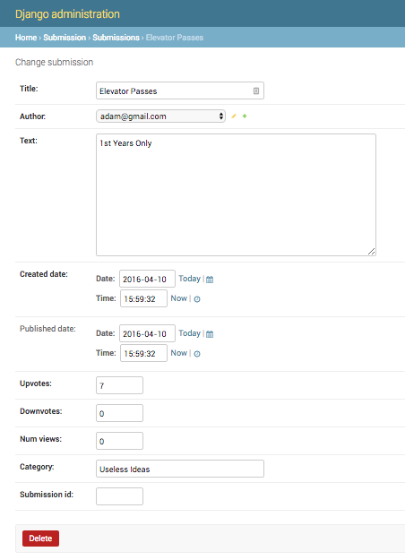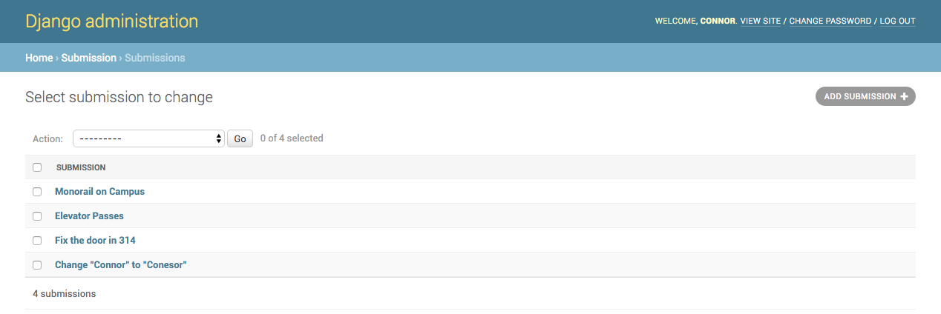

Figure 6: Administration - Submission Overview

Figure 7: Administration - Submission Listing

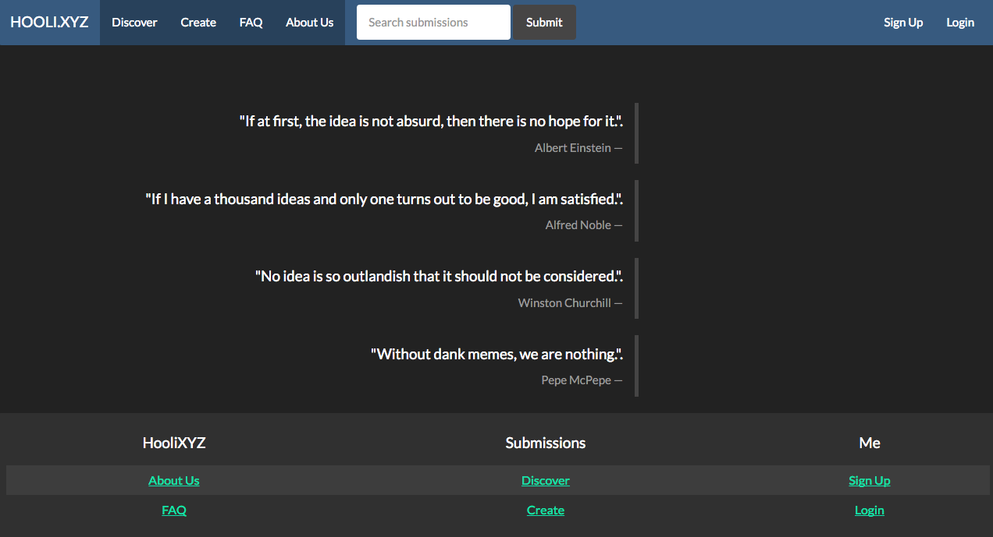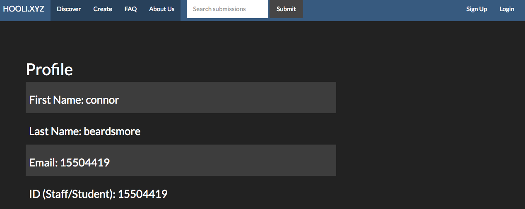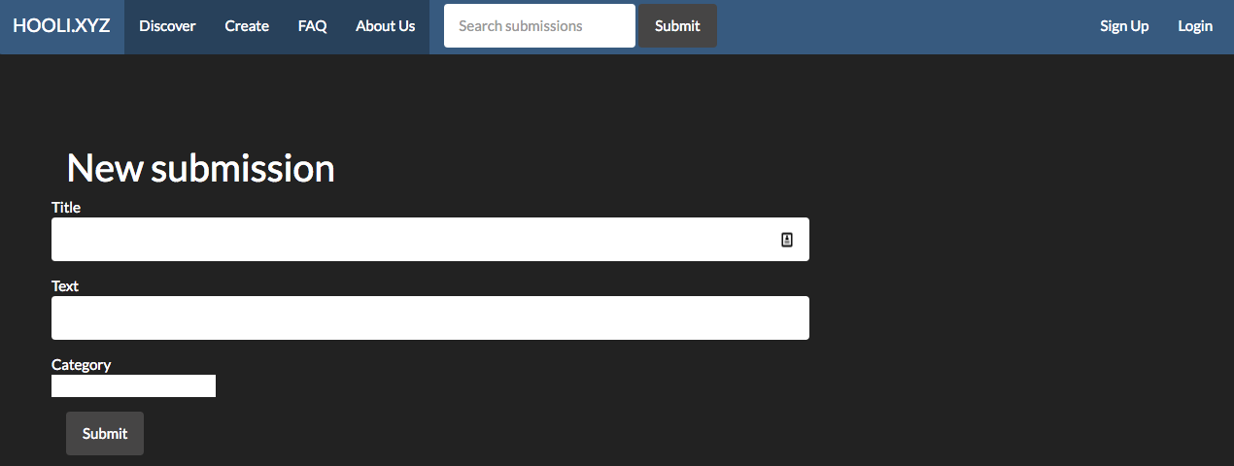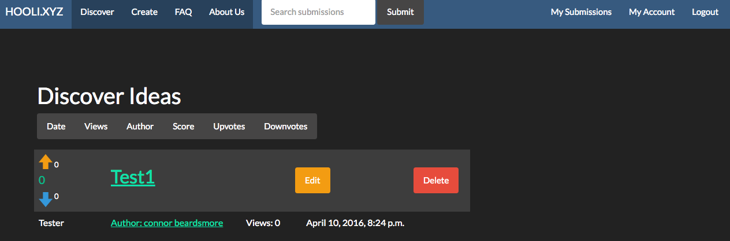

Figure 8: Home Page

Figure 9: User Profile

Figure 10: Post Submission Form

Figure 11: View Submission List